**DAYANANDA SAGAR UNIVERSITY**

**DEPARTMENT OF COMPUTER SCIENCE & ENGINEERING**

**SCHOOL OF ENGINEERING**

**DAYANANDA SAGAR UNIVERSITY KUDLU GATE**

**BANGALORE – 560068**

**A Mini Project Report**

**ON**

**“HOTEL MANAGEMENT SYSTEM”**

**BACHELOR OF TECHNOLOGY**

**IN**

**COMPUTER SCIENCE & ENGINEERING**

***Submitted by***

**TEJAAL M -ENG19CS0334**

**SNAVYA SAI M B - ENG19CS0312**

**VARSHA PREMANAND - ENG19CS0353**

**V Semester, 2021**

**Course Code: 19CS3504**

**Course: Database Management System**

**DAYANANDA SAGAR UNIVERSITY**

**School of Engineering, Kudlu Gate, Bangalore-560068**

**CERTIFICATE**

***This is to certify that Snavya Sai M B, Tejaal M, Varsha Premanand bearing USN ENG19CS0312, ENG19CS0334, ENG19CS0353 has satisfactorily completed their Database Management System Mini Project Report as prescribed by the University for the Fifth semester B.Tech. Program in Computer Science & Engineering/ Computer Science & Technology during the year 2021 at the School of Engineering, Dayananda Sagar University, Bangalore***

Date:

Faculty in Charge

**Chairman**

**Department of Computer Science & Engineering**

**ACKNOWLEDGEMENT**

The success and final outcome of this software requirement document required a lot of guidance and assistance from many people and we are extremely privileged to have got this all through the completion of the project. All that we have done is only due to such supervision and assistance and we would not forget to thank them.

We respect and thank Dr. Srinivas A , **Professor and Chairman,** for providing us an opportunity and giving us all support and guidance, which made me complete the project duly. We are extremely thankful to him for providing such a nice support and guidance, even though he has busy schedule managing the departmental affairs.

We owe our deep gratitude to **our guide** Prof. Rashmi M for guiding us all along, till the completion of our project work by providing all the necessary information for the successful completion of our mini project work.

We are thankful to, and fortunate enough to get constant encouragement, support and guidance from all Teaching staffs of the Computer Science Engineering department, which helped us in successfully completing our report. Also, we would like to extend our sincere esteems to all staff in laboratory for their timely support.

Student Names

1. Snavya Sai M B
2. Tejaal M
3. Varsha Premanand

**TABLE OF CONTENTS**

|  |  |  |
| --- | --- | --- |
| SL. NO | TOPIC | PAGE NO. |
| 1 | Cover Page | 1 |
| 2 | Certificate | 2 |
| 3 | Acknowledgment | 3 |
| 4 | Contents | 4 |
| 5 | Introduction | 5 |
| 5.1 | Problem Statement | 5 |
| 5.2 | Objective | 5 |
| 6 | System Requirements | 6 |
| 6.1 | Software and Hardware | 6 |
| 7 | System Design | 7 |
| 7.1 | ER and Class Diagram | 7 |
| 8 | System Implementation | 8 |
| 8.1 | Module Description | 8 |
| 8.2 | Important Code | 10 |
| 9 | Screenshots | 13 |
| 10 | Conclusion | 25 |
| 11 | References | 26 |

**INTRODUCTION**

**PROBLEM STATEMENT**

In our project “Hotel Management System” we have tried to show how the data/information in hotels is managed. This is just an overview of management in hotels. It manages and maintains the records of customers, rooms, employees and drivers in the hotel. The project is aimed to maintain the day-to-day state of admission/vacation of Residents, List of employees, room details etc. Main objective of this project is to provide a solution for hotels to manage most their work using computerised processes.

This software application will help admin to handle customer information, room allocation details, Payment details etc.

The rooms have different categories like single bed, double bed etc. so their charges and records will be maintained accordingly.

This software has been made in a user friendly interface, so that anyone can add, delete, update the entries and handle all the transactions easily. As a security I have provided Admin username and Password.

The project, Hotel Management System is a desktop-based application that allows the hotel manager to handle all hotel activities online. Interactive GUI and the ability to manage various rooms, employees, drivers and customers make this system very flexible and convenient. This application gives managers the power and flexibility to manage the entire system from a single online system. Hotel management project provides room booking, staff management and other necessary hotel management features. The system allows the manager to post available rooms in the system.

**OBJECTIVE**

The objective of the Hotel Management System is to develop a project which maintains booking of rooms, providing drivers, etc. It is a windows based application to be implemented in Java

The Purpose of the whole process is to ease the daily or regular activities of the Hotel Management into an automatic computerised retrievable process. The daily activities includes the Room activities, Entering details of the new customer check in, To allocate a room as per the customer need and interest, Recording the checkout time and details, Releasing or Empty of room and to record the process in a computer system for future.

Main objective of this project is to provide a solution for hotels to manage most their work using computerised processes. This software application will help admin to handle customer information, room allocation details, Payment details etc.

**SYSTEM REQUIREMENTS**

**SOFTWARE REQUIREMENTS**

1. Net Beans IDE(Front End)
2. Java Swing(Front End)
3. MySQL Workbench(Back End)

**HARDWARE REQUIREMENTS**

1. Desktop PC or a Laptop
2. Intel®️ CoreTM i3-6006U CPU @ 2.00GHz
3. 4.00 GB RAM
4. 64-bit operating system, x64 based processor
5. 1024 x 768 monitor resolution
6. Keyboard and Mouse

**SYSTEM DESIGN**

**ER diagram**

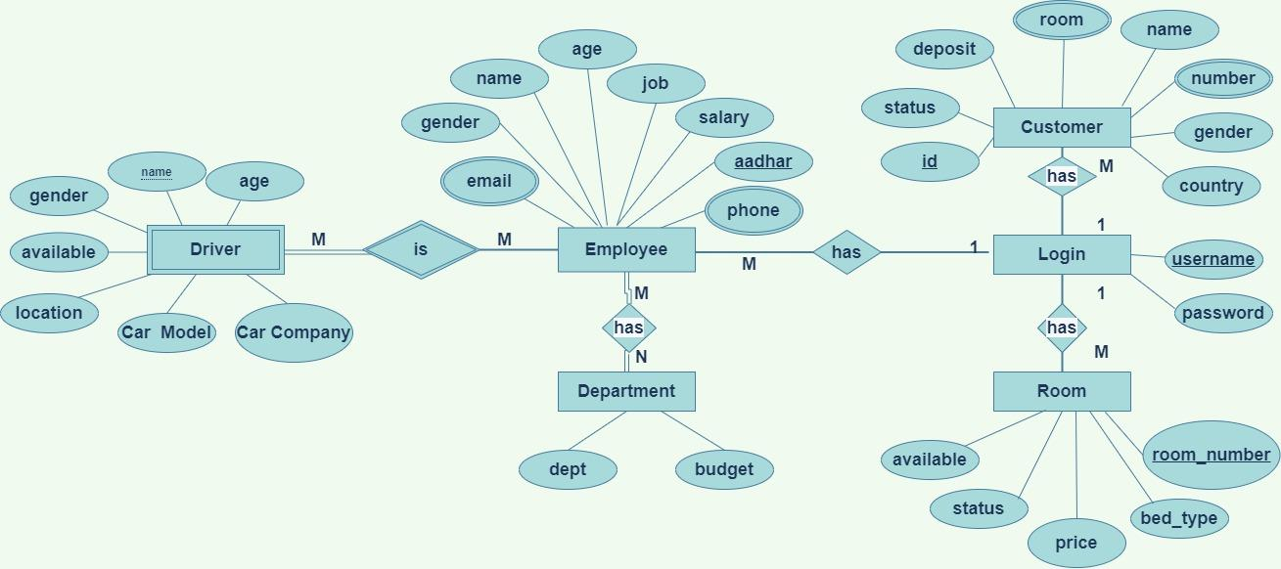**Class Diagram**

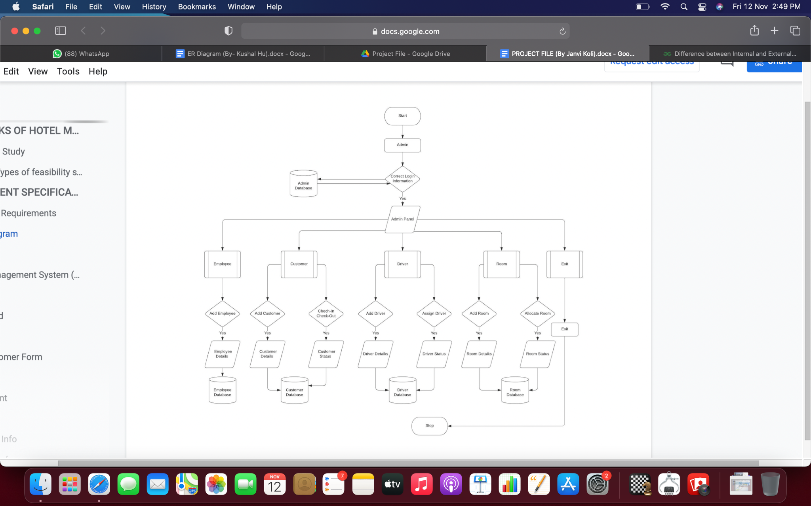

**SYSTEM IMPLEMENTATION**

**MODULE DESCRIPTION**

1. Start

2. Create a

3. Create the main class named as HotelManagementSystem that extends JFrame

implements ActionListener and add buttons login.

4. Create a database in Mysql name projecthms.

5. Import the following files -

import java.awt.*;

import javax.swing.*;

import java.awt.event.*;

import net.proteanit.sql.DbUtils;

import java.sql.*;

6. Create a Login class that extends JFrame, add text label and password label to the

JFrame and two-button Login.

7. Enter the user name “admin” and password “password” to click the login button to

confirm access.

8. Create a class connection(conn) and declare a variable c with data type Connection. This

creates a connection by using “com.mysql.jdbc.Driver" .Connect the code

with database using Driver Manger using the following string

"jdbc:mysql://localhost/projecthms","root","password";

9. Create a class Dashboard that extends JFrame, Add the following buttons to the

JFrame , HOTEL MANAGEMENT and ADMIN, where HOTEL MANAGEMENT button has RECEPTION item and ADMIN button has items ADD EMPLOYEE, ADD ROOMS, ADD DRIVER.

10. ADD EMPLOYEE calls AddEmployee class, ADD ROOMS calls AddRoom class and ADD DRIVER calls AddDriver.

11. Now create AddEmployee Class that contains input fields where the employee data

can be given as an input and then using a button submit stores the data of the

employee in the MySQL database in table called “employee” using JDBC connect.

Same thing for the AddRoom, the input details of the room will be stored in the

MySQL database in the table “room” using JDBC connect, inside the ActionPerformed block.

12. Once the valid details are entered the button submit, stores the details in the database

and returns to the previous class Frame or by clicking Back, it will return to the

previous class file.

13. HOTEL MANAGEMENT button in the main menu - the action performed by this

button will lead to the Reception class where, New customer form , room, all employee

info, customer info, manager info, checkout, update check status, update room

status and main menu buttons exist. using these buttons will lead to respective class

file.

14. Now New Customer Form button will lead to Customer form class where the details

of a new customer can be added and then step 12 will be performed.

15. Now Room button will lead to room class file that will display all the rooms in the

form of a table and the button Load data will refresh if any changes are updated in

the database. And the button Back will take back to the reception screen.

16. Now all employee info button will lead to employee info class file that will display all

the employees in the form of a table and the button Load data will refresh if any

changes are updated in the database. And the button Back will take back to the

reception screen.

17. Now Customer info button will lead to employee info class file that will display all the

customers in the form of a table and the button Load data will refresh if any changes

are updated in the database. And the button Back will take back to the reception

screen.

18. Now manager info button will lead to employee info class file that will display all the

managers in the form of a table and the button Load data will refresh if any changes

are updated in the database and the button Back will take back to the reception

screen

19. The Check out button will lead to check out class where there exists a choice box

which displays all the checked in customer id’s and once selected there’s an image

button that will show the corresponding room number in the below text field. With

help of the button Check Out, once action is performed the details of the customers

will be removed from the checked in table and then the room will be available for other

customers. And reception class will be visible. Or with the Back button, the action

can take back to the reception frame.

20. The Update Check status button will lead to checkin class where there exists a choice

box which displays all the checked in customer id’s and once selected there is a

check button that will show the corresponding details of the customer in the below

text fields. And the amount paid and the pending amount can be seen and adjusted

here. Once everything is done the button update will update the details in the

database and will return to the reception frame. Or with the Back button, the action

can take back to the reception frame.

21. The Update room status button will lead to room class where there exists a choice box

which displays all the checked in customer id’s and once selected there’s a check

button that will show the corresponding details of the customer in the below text

fields. The room cleaning status and the availability can be seen and adjusted

here. Once everything is done the button update will update the details in the

database and will return to the reception frame. Or with the Back button, the action

can take back to the reception frame.

22. Finally, there exists a button Main Menu, the action performed by this will take back

to the main menu frame.

**MAIN CODE**

**Connection**

package hotel.management.system;

import java.sql.*;

public class conn {

//interface declaration

Connection c;

Statement s;

//constructor

public conn(){

try{

Class.forName("com.mysql.jdbc.Driver"); //Registering the driver

c = DriverManager.getConnection("jdbc:mysql:///projecthms","root","Snavzz030901$$"); //Establishing connection

s = c.createStatement(); //creating a statement

}

catch(Exception e){

System.out.println(e);

}

}

}

**Hotel Management System(Home Page)**

package hotel.management.system;

import java.awt.*;

import javax.swing.*;

import java.awt.event.*;

public class HotelManagementSystem extends JFrame implements ActionListener{

//constructor

HotelManagementSystem(){

setBounds(300,150,800,430);

ImageIcon i1 = new ImageIcon(ClassLoader.getSystemResource("hotel/management/system/icons/first.jpg"));

JLabel l1 = new JLabel(i1);

setLayout(null);

l1.setBounds(0,0,800,430);

add(l1);

JLabel l2 = new JLabel("Hotel Management System");

l2.setBounds(20,0,1000,90);

l2.setForeground(Color.DARK_GRAY);

l2.setFont(new Font("serif",Font.PLAIN,70));

l1.add(l2);

JButton b1 = new JButton("Next");

b1.setBounds(680,360,100,20);

b1.setBackground(Color.LIGHT_GRAY);

b1.setForeground(Color.BLACK);

l1.add(b1);

b1.addActionListener(this);

setVisible(true);

while(true){

l2.setVisible(false);

try{

Thread.sleep(500);

}catch(Exception e){}

l2.setVisible(true);

try{

Thread.sleep(500);

}catch(Exception e){}

}

}

public void actionPerformed(ActionEvent ae){

new Login().setVisible(true);

this.setVisible(false); //closes the first frame once you click on next

}

public static void main(String[] args){

new HotelManagementSystem();

}

}

**SCREENSHOTS**

**Home Page**

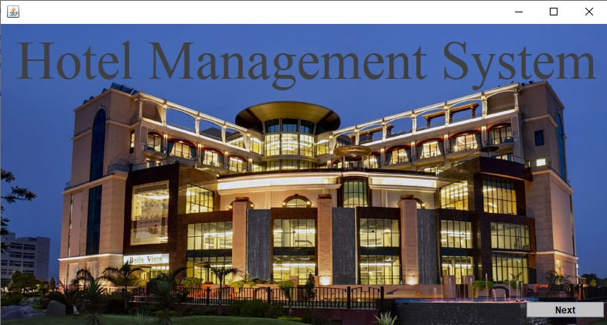

**Login Page**

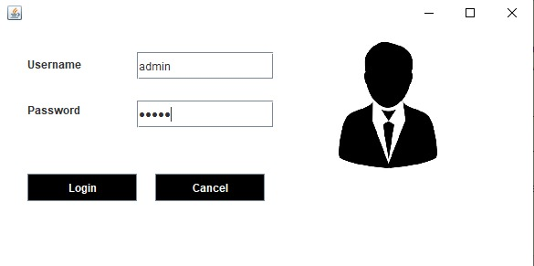

**Dashboard**

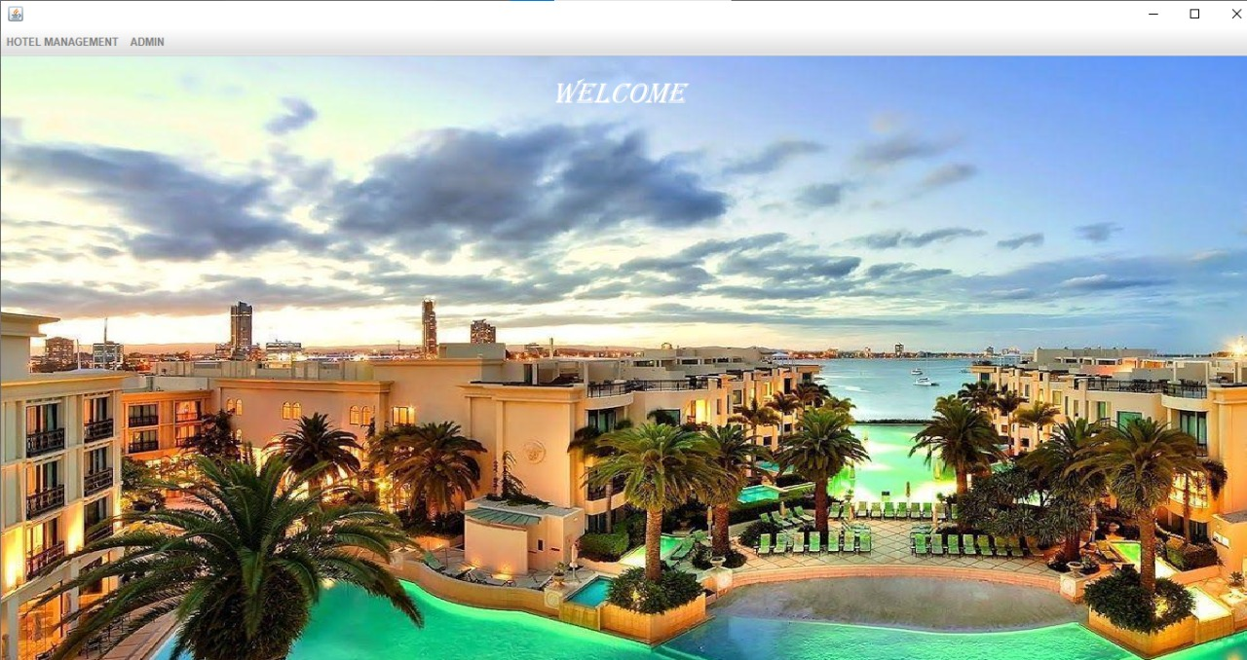

**Add Employee**

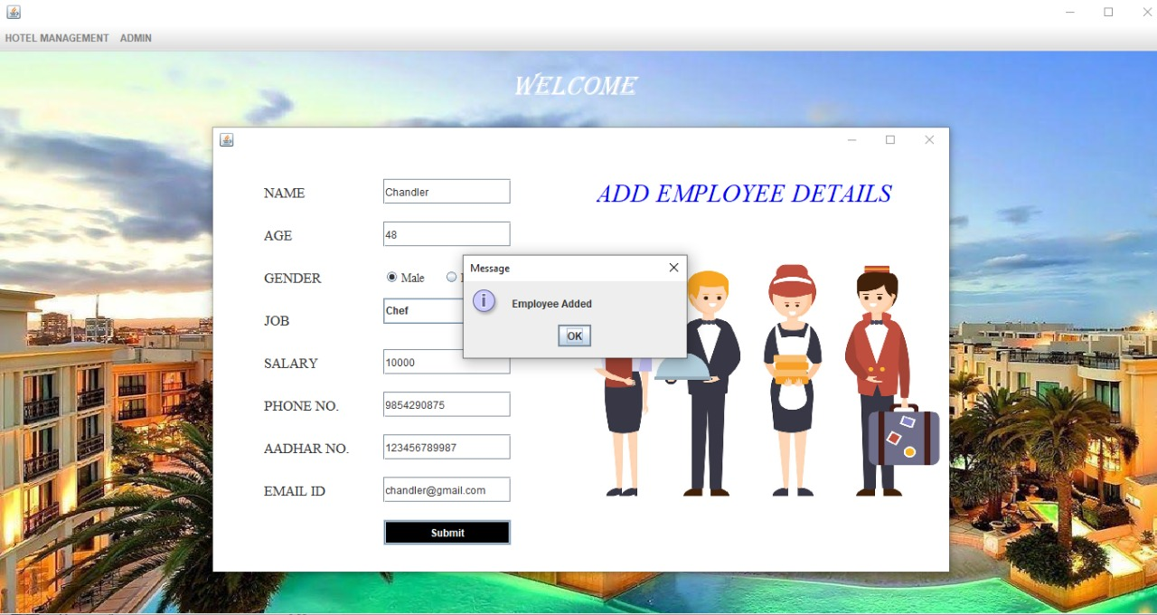

**Add Room**

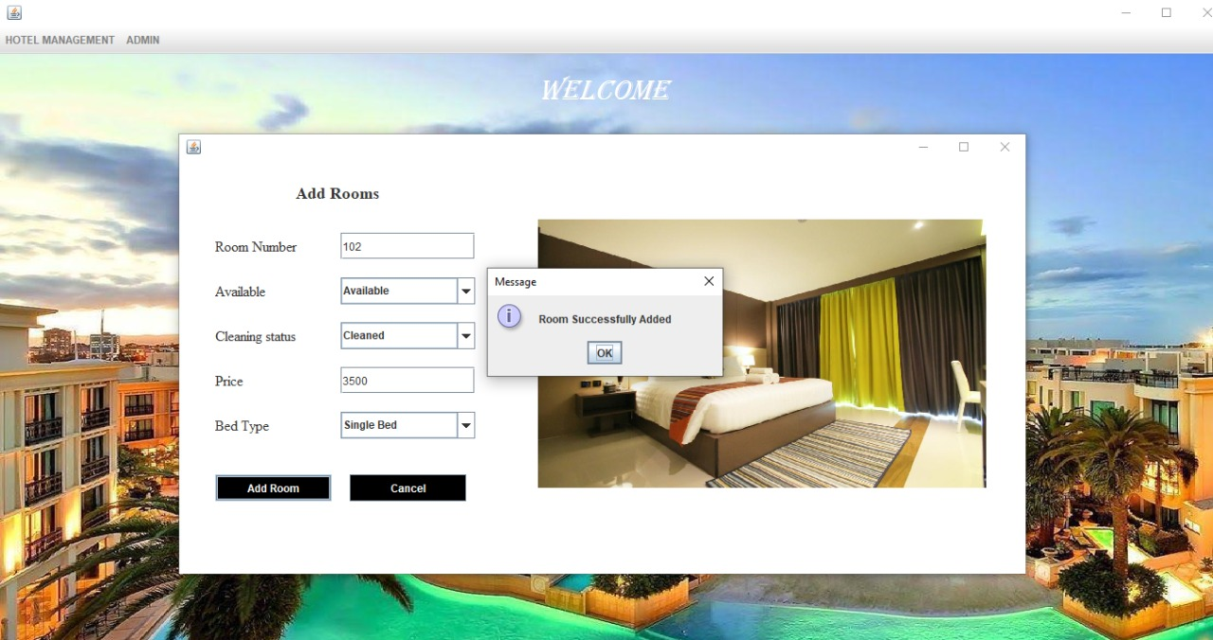

**Add Drivers**

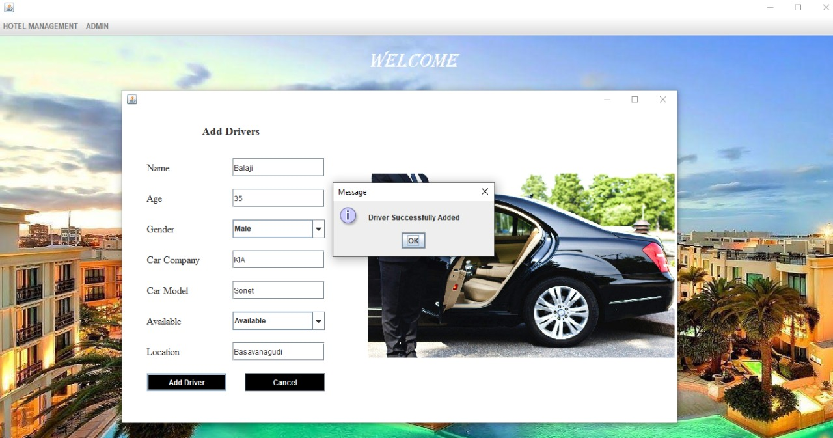

**Reception**

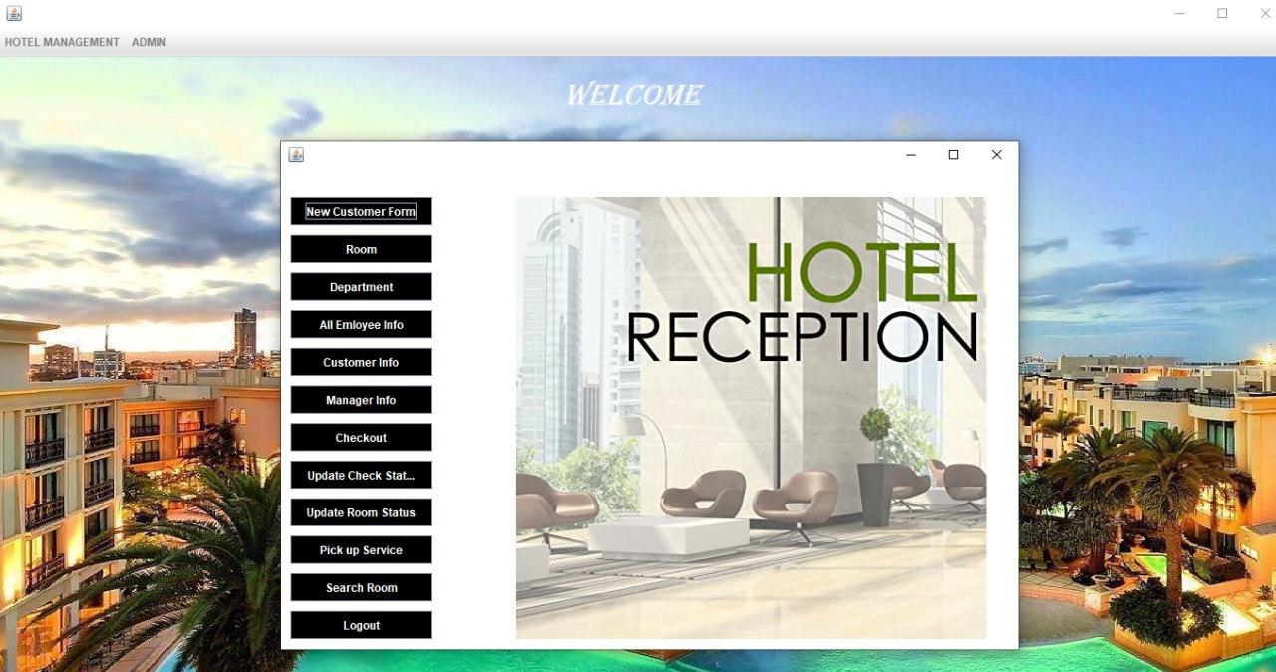

**Add Customer**

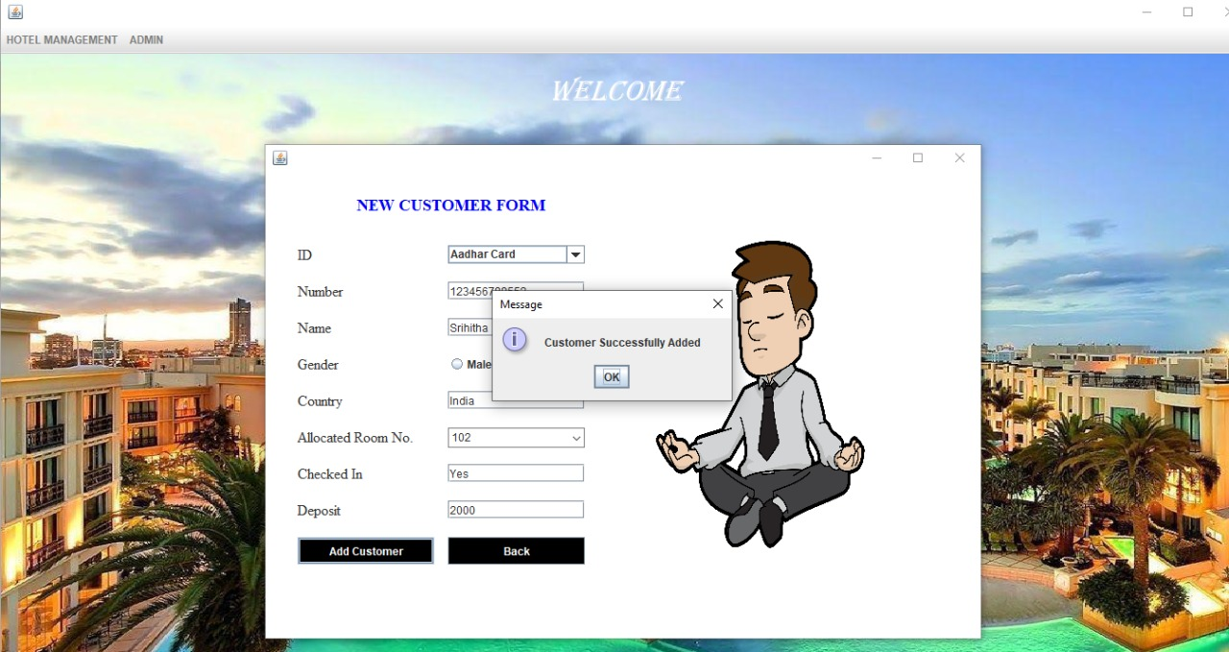

**Room Details**

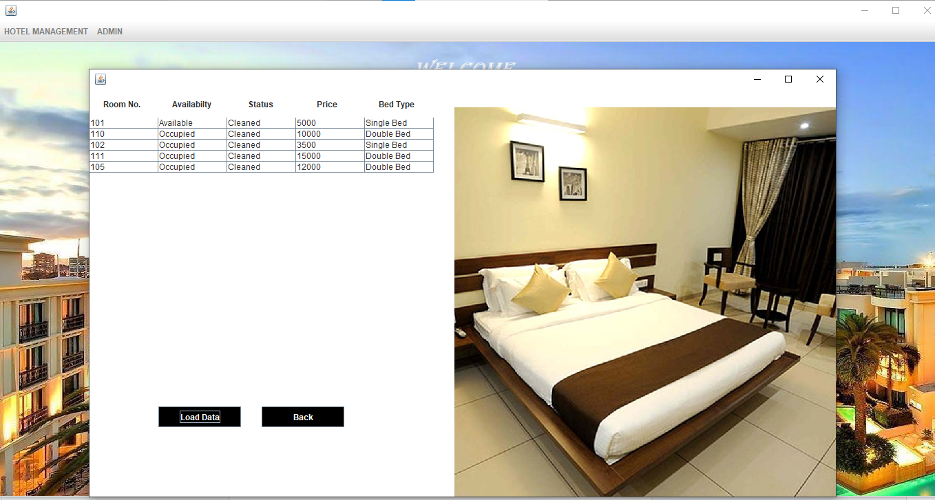

**Employee Details**

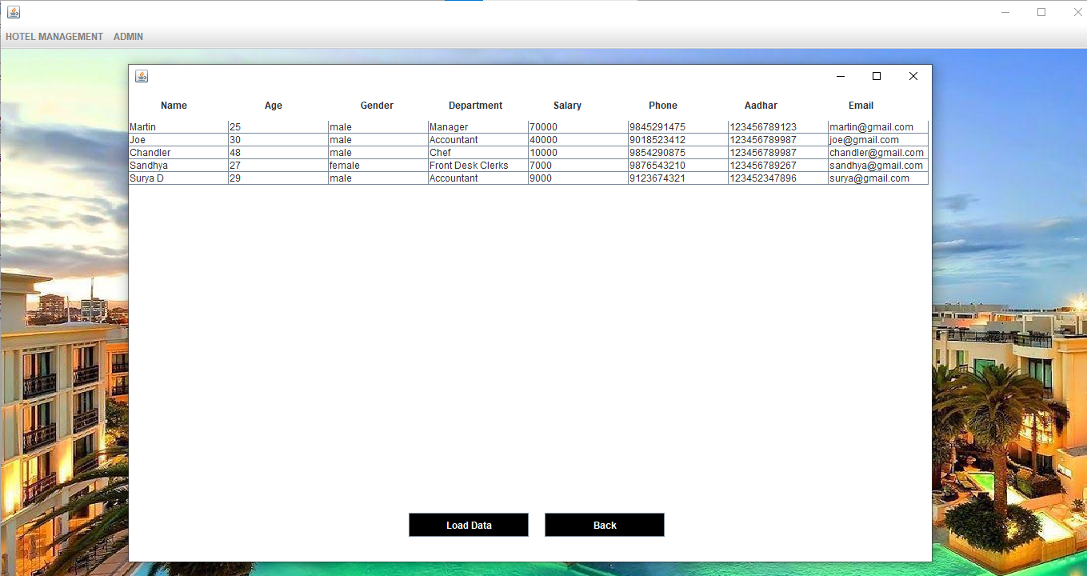

**Customer Info**

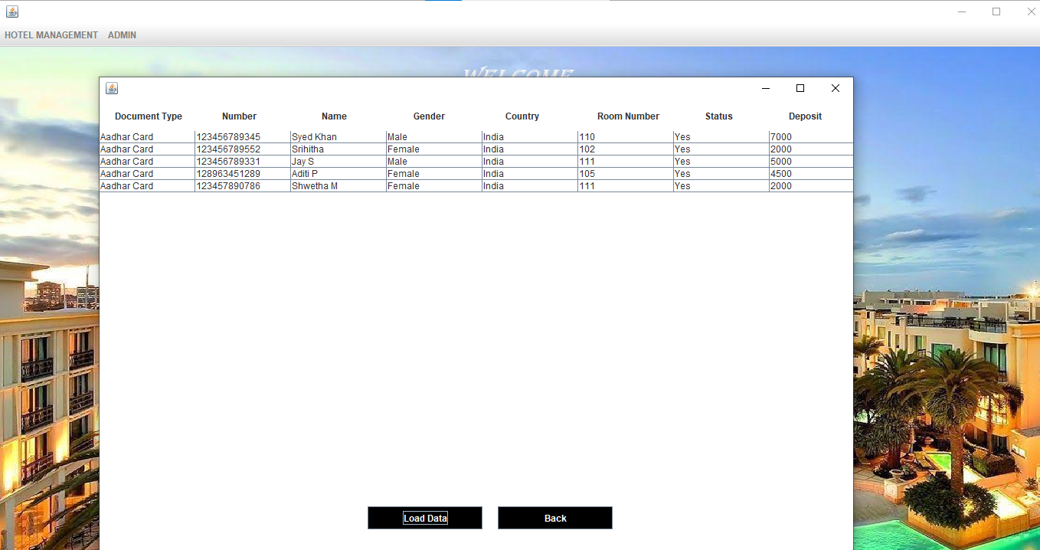

**Manager Info**

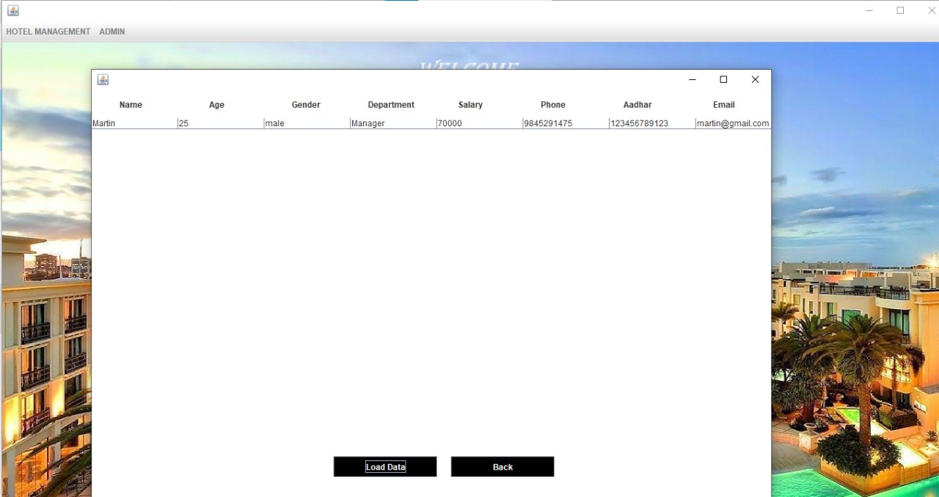

**Check-In Details**

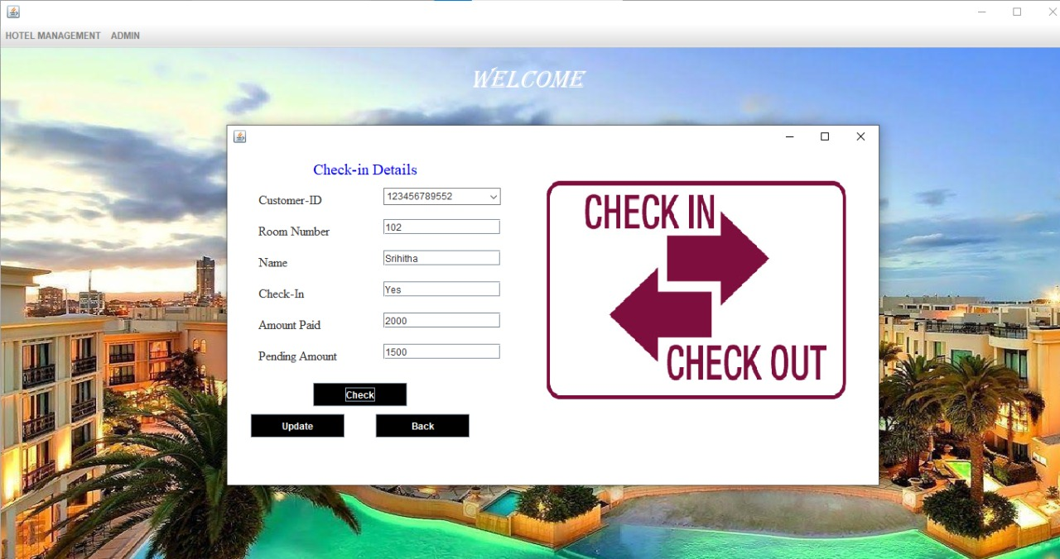

**Room Status**

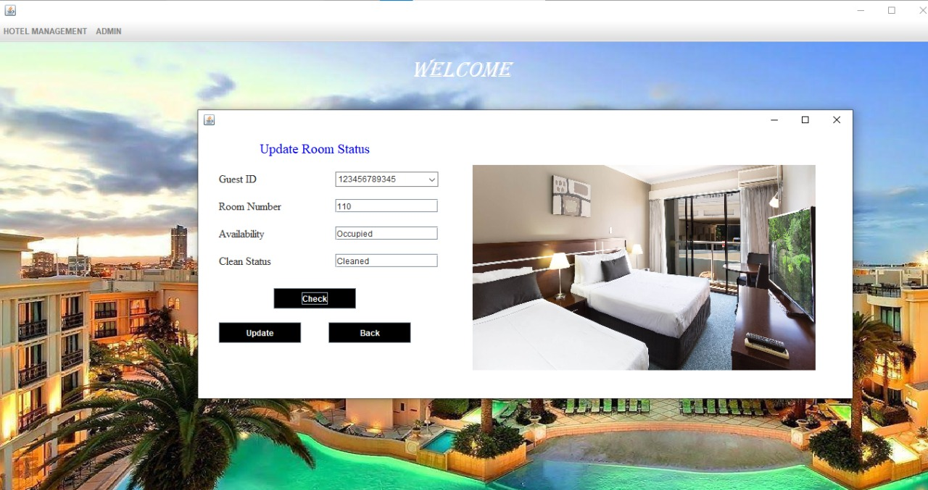

**Pick-Up Service**

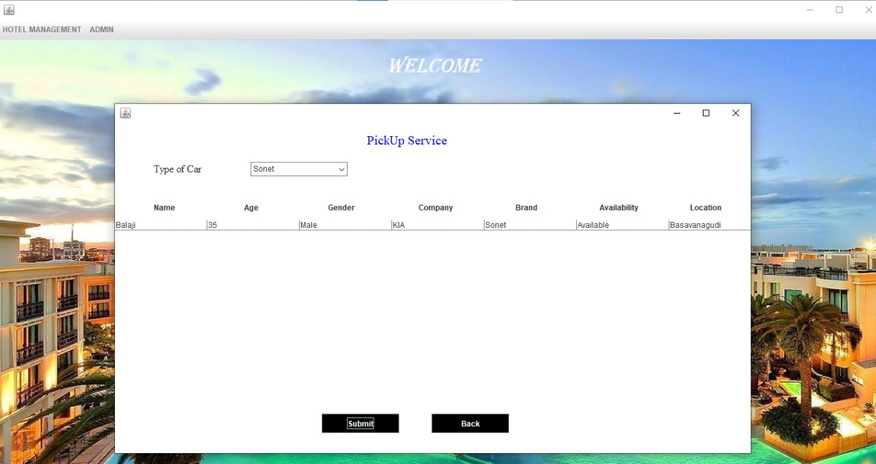

**Search For Room**

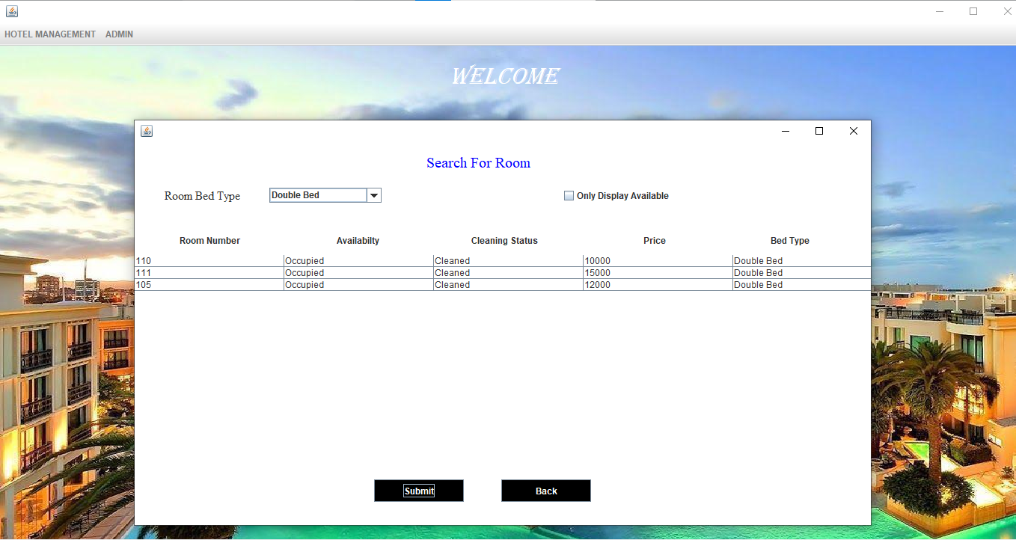

**Available Single Beds**

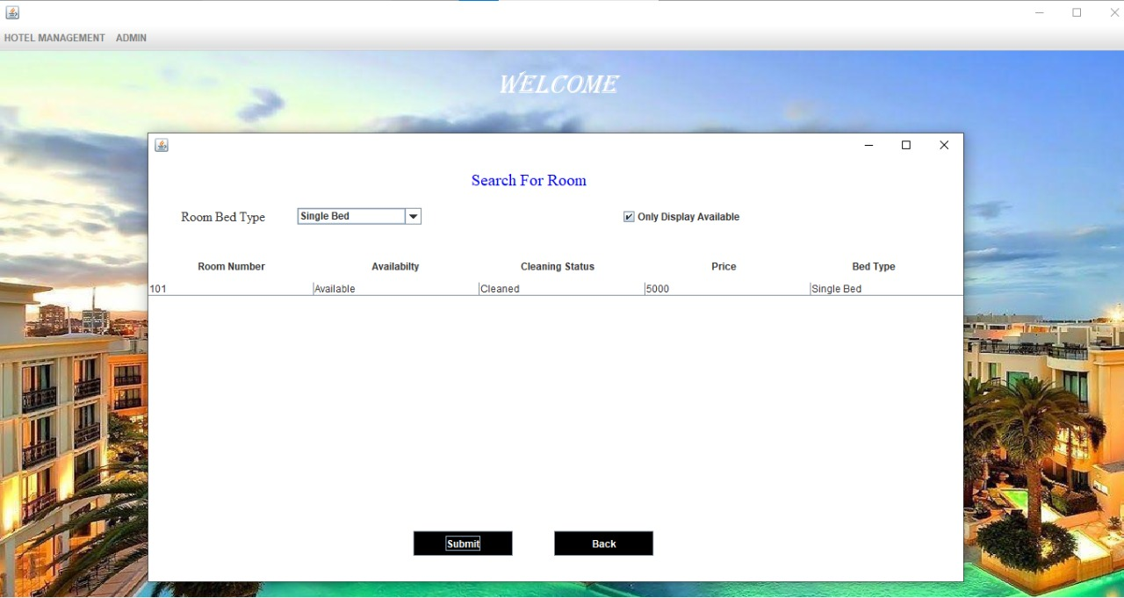

**CheckOut**

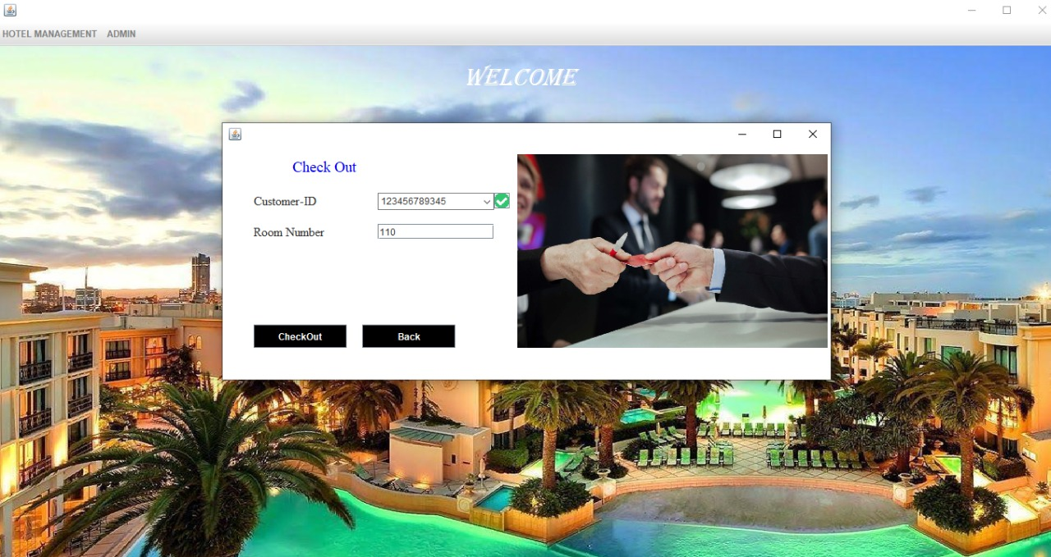

**TABLES**

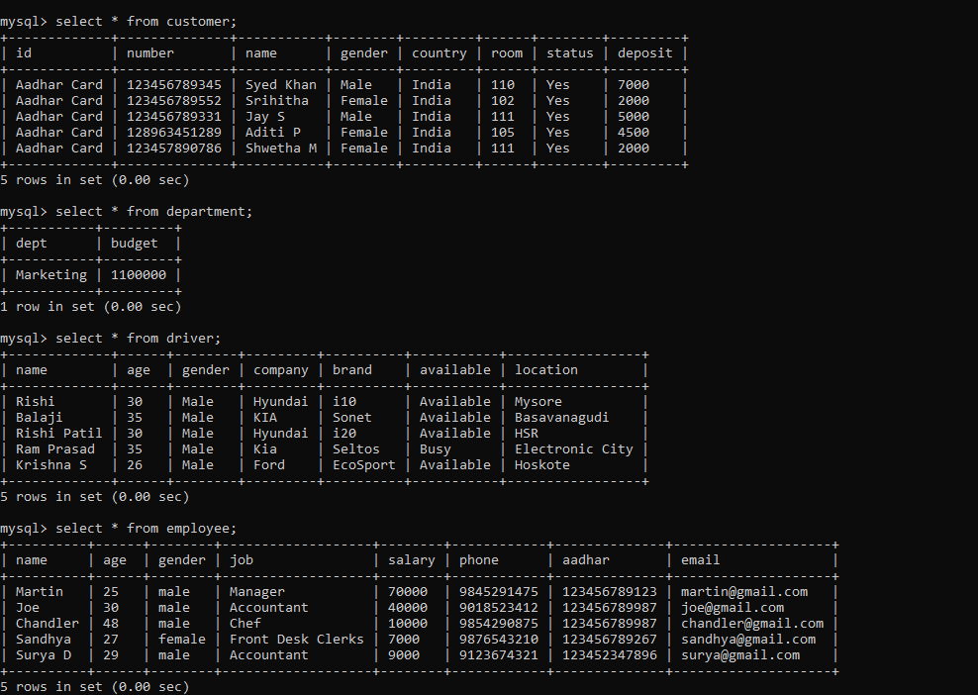

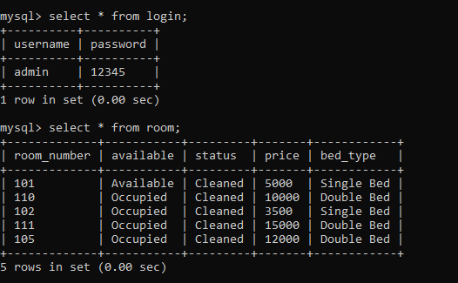

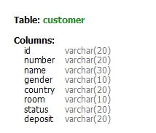

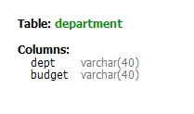

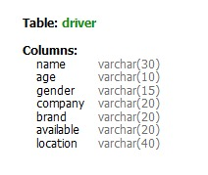

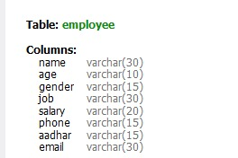

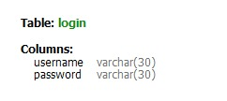

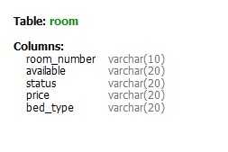

**CONCLUSION**

In this project we have tried our best to make user friendly software. This software can be handled by any person who has little idea of computers. In this software we have tried to meet most of the requirements of the present hotel management system including maintaining details of customers, rooms, employees and drivers. We have also added the option to update the details of customers, rooms and employees.

**Future Implementation**

* We would like to implement validation ,for phone number ,id proofs, password and username.
* We would also like to include multiple admin logins ,so that it could be used by many users.

**REFERENCES**

<https://youtube.com/playlist?list=PL5BFcXE899zw2dGJkCKjiLCD-wqCr1HKH>

**THANK YOU**